VTrckS:
SAP Functional Specification Document - Enhancement
Object ID | E008
Object Type | Enhancement
Object Title | Fiori-Awardee-UI-Orders
Process Area | Procurement & Bulk Ordering Awardee Spend Plan  Provider Orders & Fulfillment  Awardee Returns, Wastage, & Transfers
Sub Process Area | Provider Order
Original Author(s) | Jigisha Vaddhi
Current Revision Author(s) | DJ Fesko

Table of Contents
1 Executive Summary 8
1.1 Overview 8
1.2 Business Driver 8
1.3 As-Is process 8
1.4 To-Be process 8
1.5 Business Risks 8
1.6 Requirements Traceability Matrix 8
1.7 Impacted Subprocesses 9
1.8 Assumptions 9
1.9 Impacted Systems 9
2 Business Process Considerations 10
2.1 Process Description and Flow 10
2.2 Dependencies 10
2.2.1 Configuration Dependecies ……………………………………………………………………………………………………………… 10
2.2.2 Development Dependencies ……………………………………………………………………………………………………………. 10
2.2.3 Execution Dependencies ………………………………………………………………………………………………………………….. 11
2.3 Expected System Load 11
3 Functional Design Considerations 12
3.1 Detailed Description of Enhancement 12
3.2 Access Method or Path 12
3.3 Required Custom Table 12
3.4 User Interface Screen Flow 13
User Interface Screen Layout and Field List …………………………………………………………………………………………………. 13
3.4.1.1 User Interface Screen Layout …………………………………………………………………………………………………….. 13
3.4.1.2 User Interface Screen Field List …………………………………………………………………………………………………. 13
3.4.1.3 User Interface Processing Details ………………………………………………………………………………………………. 14
3.4.1.4 User Interface Error and Exception Handling Details …………………………………………………………………. 14
3.5 Performance Requirements 14
4 Security and Controls 15
4.1 Security Requirements 15
4.2 Auditing and Control Requirements 16
5 Functional Unit Test Scenarios 17
6 Attachments and Documentation 18

Document Control Information

Document Edit History
Version | Date | Additions/Modifications | Prepared/Revised by
Version 1 | 03/31/2026 | Initial Version | Jigisha Vaddhi
Version 2 | 07/22/2026 | Channel Field (PO Type) to be derived to “UI” when order is created from direct entry | DJ Fesko

Document Review and Sign Off
The approval/sign-off is to proceed with build, acknowledging the documented open items and red-text sections are pending confirmation and will be completed as we proceed to future phases.
Reviewed By:
The “Reviewed By” signature indicates the individual(s) who reviewed this document for content and clarity, and to the best of their knowledge, this document satisfactorily achieves the purpose and scope defined herein:
 | Name | Title/Role <Designation, Department>
Reviewed By
Signature |  | Date:
Reviewed By
Signature |  | Date:

Approved By:
The “Approved By” signature indicates the individual(s) who approved this document for content and clarity, and to the best of their knowledge, this document complies with corporate policies and procedures:
 | Name | Title/Role <Designation, Department>
Approved By | Jeanne Santoli | VTrckS Business Owner
Signature | Jeanne Santoli | Date: 05/11/2026
Approved By
Signature |  | Date:

Open Items

Date Opened | Description | Assigned to | Due Date | Status
04/21/2026 | CDC Needs to review the standard Fiori App / custom Fiori app to determine it meets CDC requirements.

References

Document ID | Description | Version
BPD SO-010-010 | Business Process Document - Provider Order Processing
Fit-Gap Analysis | CDC VTrckS Fit-Gap Analysis
SO-010-010 Process Flow | Process Flow – Provider Order Processing

Acronyms and Definitions

Acronym/Term | Description
VTrckS | Vaccine Tracking System
S/4HANA | SAP S/4HANA
NDC | National Drug Code
ExIS | External Immunization Information System

Executive Summary
This Functional Specification Document (FSD) defines the business requirements and functional design for Enhancement E008, "Fiori - Awardee UI - Orders." The enhancement provides Awardee and CDC users with a Fiori-based user interface for managing provider vaccine orders, including order creation, order cancellation, order search and display, and Inventory on Hand (IoH) submission during order creation.

Overview
Enhancement E008 delivers a custom SAP Fiori application that enables Awardee users and CDC users to perform provider order management activities within S/4HANA. In the target system, these capabilities will be delivered through a Fiori-based interface that integrates with the S/4HANA sales order framework. The enhancement consolidates six gap requirements identified in the Fit-Gap analysis:
- Copy an existing vaccine order to create a new order (SO-010-010-010)
- Order entry through Fiori by Awardees, interfaced via API (SO-010-010-050)
- Cancel provider order or line item with role-based restrictions (SO-010-010-160)
- Search and list provider orders using multiple search criteria (SO-010-010-260)
- Display provider order details including partner functions, NDCs, and quantities (SO-010-010-270)
- Submit Inventory on Hand (IoH) during provider order creation in Fiori, with pre-population from consignment stock (SO-010-030-030)
- Awardee fixes data issues and resubmits when the order has failed validation requirements (SO-010-010-090)
- Create Return Order with Reference to Provider Order (RW-010-010-010)
- Create a replacement order from a sales order (SO-020-010-020)
In the to-be system, the VTrckS Vaccine Request maps to an S/4HANA Sales Order. Status management and business rule validations will be implemented via configuration and custom enhancements, respectively. The Fiori application will serve as the primary Awardee-facing interface for order lifecycle management.

Business Driver
The CDC is migrating VTrckS from SAP CRM/ECC to S/4HANA to modernize the vaccine ordering and distribution platform. E008 is required because standard S/4HANA sales order Fiori applications (e.g., F3893 - Manage Sales Orders) do not natively support the CDC-specific order workflows, including,CDC-specific business validation integration, role-based cancellation rules differentiating pre- and post-approval permissions for direct ship vs. non-direct ship items, and inline IoH submission during order creation. Without E008, Awardee users would lack a functional interface to create, manage, search, and cancel provider orders within the new S/4HANA environment.

Business Risks
If E008 is not developed, Awardee users will have no Fiori-based interface to create, edit, cancel, search, or display provider orders in S/4HANA, resulting in a complete loss of order management capability for that user population. Failure to implement role-based cancellation controls risks unauthorized order cancellations, leading to incorrect budget releases, and downstream fulfillment discrepancies. Without inline IoH submission during order creation, providers will need to submit IoH through a separate process, increasing manual effort and the risk of inventory data being out of sync with order activity. Without the copy-order functionality will reduce operational efficiency, requiring users to manually re-enter all order data rather than referencing an existing order.

Requirements Traceability Matrix

L4 Task ID | L4 Description | Description
SO-010-010-010 | Copy Existing Vaccine Order | A user can create a vaccine order with reference to an existing vaccine order.
SO-010-010-050 | Order Entry through Fiori by Awardees | Orders are interfaced into VTrckS via API. The order will be validated against the spend plan and business validation rules to enforce data quality, eligibility, budget, contract and attribute checks.
SO-010-010-090 | Awardee fixes data issues and resubmits | Once an order has failed (hard stop error) the validation requirements, the data must be corrected. The order will be updated and saved.
SO-010-010-160 | Cancel Provider Order / Line Item | User should be able to cancel an order/line item on the Provider Order for General Data that is not completed or cancelled. Cancellation triggers business rules, releases committed budget and SPC allocation, and updates order statuses. Role-based restrictions apply pre- and post-approval.
SO-010-010-260 | Search/List Provider Order | The user should be able to search and list provider orders using different fields such as Provider PIN, NDC Code, Provider Order Number. This applies to all orders, not just completed ones.
SO-010-010-270 | Display Provider Order | User should be able to display the provider order to see all details, such as partner functions (sold-to, ship-to), NDCs, and quantity ordered. This applies to all orders, not just completed ones.
SO-010-030-030 | Submit IoH when creating the provider order in Fiori | When creating a provider order, the IoH for that provider can be updated. Consignment stock pre-populates IoH with NDC, Lot Number, Qty, and Expiration Date. IoH is created with status "Submitted."
SO-020-010-020 | Create a replacement order from a sales order | CDC users initiate a replacement order by directly referencing a provider (sales) order. This process skips budget validations and does not affect the awardee’s financial balances.
RW-010-010-010 | Create Return Order with Reference to Provider Order | A user can create a return order with reference to an existing Provider order.

Assumptions
- The S/4HANA Sales Order document type and status profile configuration for provider orders will be completed prior to E008 development. The VTrckS Vaccine Request maps to an S/4HANA Sales Order.
- Business validation rules (order save validations) are defined and implemented in E006. E008 will reference E006 validation logic during order creation and cancellation events.
- The mandatory partner functions for provider orders (Sold-to Party, Bill-to Party, Ship-to Party, Payer, Contact Person, Employee Responsible) will be configured in S/4HANA. Grantee maps to Sales Office, and Vendor maps to Plant—neither requires a partner function.
- Provider order statuses in S/4HANA will use User Status profiles with the following values: In Process-Request, Order on Hold - Request, Approved Request, Approved by Grantee - Req, Rejected, Cancelled-Request, and Completed.
- The IoH submission functionality within the order creation flow will leverage the same consignment stock logic defined in E007 (Fiori - Awardee UI - Support Documents).
- Business Partner (BP) master data for Providers and Awardees will be migrated and available in S/4HANA prior to order processing.
- The fulfillment process (direct ship and non-direct ship via distributor, EDI integration, ASN receipt, delivery, and PGI) remains as-is and is outside the scope of E008.
- The standard Fiori app F3893 (Manage Sales Orders) serves as the baseline reference.

Impacted Systems
S/4 HANA BW Distributor UFMS Manufacturer

Business Process Considerations

Process Description and Flow
Enhancement E008 supports the Provider Order Processing and the Inventory on Hand Management within the Provider Orders and Fulfillment process group. Providers submit requests for vaccines through their Awardee's immunization information system or designated ordering portal, specifying quantities and types required to serve their patient populations. The order is validated by business validation rules. Once approved, the order is processed and vaccines are shipped directly to the provider's facility, ensuring timely and secure delivery for patient care.
 CDC Vaccine Tracking System Migration to S_4HANA_SO-010-010 Provider Order_VF.docx
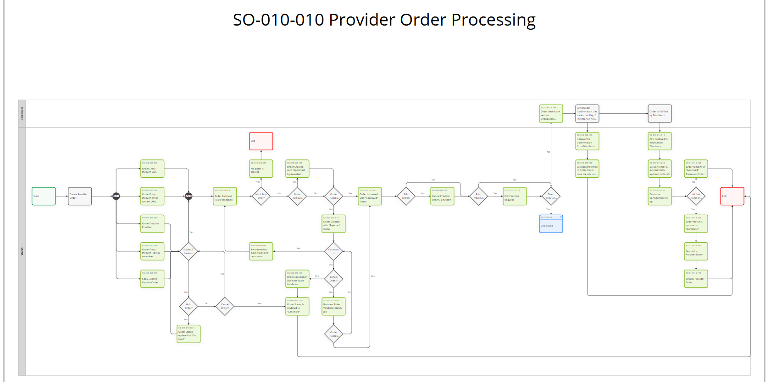

Provider Order Processing:
The end-to-end provider order lifecycle within the scope of E008 follows this sequence:

Order Creation: A user initiates a new provider order through the Fiori interface. The user may create an order from scratch by entering all required fields, or may copy an existing vaccine order to pre-populate header and line-item data.

Validation and Status Assignment: During order entry in S/4HANA, business validation rules (E006) are applied. If the order passes all validations, it is created with "1D Approved Request " status. If the order fails with a hard stop (e.g., missing mandatory fields, unauthorized access, invalid NDC), no order is created. If the order fails with a soft stop (e.g., budget exceeded, supporting documentation missing, attribute mismatch), the order is created with "1C Rejected" status and the Awardee must fix data issues and resubmit.

Approval Process: Orders with "1C Rejected" status can be corrected by the Awardee and resubmitted. A batch job runs business validation rules against rejected orders within 60 days of creation. Once validations pass, the order is automatically approved. Orders can also be manually approved by Awardee users.

Order Cancellation: Users can cancel an order or individual line items for orders that are not completed or already cancelled. Cancellation triggers business rules that immediately release committed budget and SPC allocation and update order statuses. Before order approval, both Awardee and CDC users can cancel any order or line item (direct ship or non-direct ship) and order has ‘1F Cancelled’ status. After order approval, only CDC users can cancel direct ship line items, while Awardees can still cancel non-direct ship orders or line items. When the status is "1D Approved," only the status (to Approved by Awardee or Cancelled) and Rejection Reason can be changed. When the status is "1E Approved by Awardee," the status can be changed to 1F Cancelled, Rejection Reason can be changed, Category can be edited, but Priority and Order Reason cannot be edited. Refer to details : order cancellation included in E006

Order Search and Display: Users can search and list provider orders using fields such as Provider PIN, NDC Code, and Provider Order Number. This capability applies to all orders regardless of status. Users can display full order details including partner functions (sold-to party, ship-to party), NDCs, and quantities ordered.

Inventory on Hand Management:
When creating a provider order through the Fiori interface, the user may also update the IoH for that provider. Consignment stock is used to pre-populate the IoH with vaccines and quantities. The IoH details—NDC, Lot Number, Qty, and Expiration Date—are pre-populated from current customer consignment data. The IoH is then created with status "Submitted." This is distinct from Doses Administered, which only uses the vaccines from consignment stock for pre-population.

Dependencies

Configuration Dependencies
The configuration dependencies section will be updated during the build phase to include a link to the configuration document once it has been created and is made available to CDC for review.
L4 Task ID | Description | Describe the dependency
L4 Task ID | Description | Describe the dependency | Comments
SO-010-010-060 | Order Status updated to "1B On Hold" | When a provider order has been determined to need being held, the order status is updated to On Hold.
SO-010-010-080 | No order is created | An order hits a hard stop, and no order is created when fundamental validations fail (e.g., missing mandatory fields, unauthorized access, invalid NDC).
SO-010-010-090 | Awardee fixes data issues and resubmits | Once an order has failed (hard stop error) the validation requirements, the data must be corrected. The order will be updated and saved.
SO-010-010-100 | Order Created with "1E Approved by Awardee" Status | Once an order has passed the validation process, the order is created with Awardee Approval Required Status.
SO-010-010-110 | Order Created with "1C Rejected" Status | Orders may have a "soft stop" and are created with a rejection/hold status. Examples of these may be budget exceeded, supporting documentation missing, attribute mismatch.
SO-010-010-130 | Order Status is Updated to "1F Cancelled" | When a rejected order has been determined to need cancellation, the order status is updated to Cancelled. No further action can be taken on this order.
SO-010-010-150 | Order is created with "1D Approved" Status | The order can be manually or automatically approved based on validation rules. Once the order has been approved, it is saved with Approved Status.
SO-010-010-170 | Print Vaccine Request | Print Vaccine Request enables users to generate a standardized form of a vaccine order when required.
SO-010-010-180 | Order details are sent to Distributors through EDI | Order details are transmitted from VTrckS to the distributor’s system via Electronic Data Interchange (EDI), enabling real-time, automated sharing of order information. This integration streamlines the fulfillment process, ensures accurate data exchange, and allows the distributor to process, ship, and update order statuses efficiently back to VTrckS.
SO-010-010-190 | Receive the Confirmation from Distributor through EDI. | Once the distributor receives the order details, a confirmation is sent back to VTrckS through EDI.
SO-010-010-200 | Set backorder flag in order line in case there is no inventory available | When there is no inventory available, the distributor sends the backorder flag at the order line item level, which gets updated in VTrckS.
SO-010-010-210 | ASN Received in VTrckS from Distributor | After fulfilling the order, the distributor sends an Advance Shipping Notice (ASN) to VTrckS, providing detailed shipment information such as contents, quantities, and delivery status.
SO-010-010-220 | Delivery and PGI automatically updated in VTrckS | Delivery and Post Goods Issue (PGI) statuses are automatically updated in VTrckS upon receipt of shipment details, reflecting completed deliveries.
SO-010-010-230 | Customer Consignment Fill-up | Once the NDC/Material is shipped to the provider, the customer consignment is filled up. This goods movement records the transfer of inventory into the provider’s consignment stock, pre-populating Inventory on Hand (IoH) data. The updated IoH is then used when creating the IoH Supporting Document.
SO-010-010-240 | Order remains in "1D Approved" Status until it is fulfilled | The order remains in "Approved" status until it is fully fulfilled by the distributor. This status indicates that the order has passed all necessary validations and approvals, but the fulfillment process (such as shipment and delivery) has not yet been completed. Once all items are shipped, the order status will transition to reflect fulfillment.
SO-010-010-250 | Order status is updated to "1G Complete" | The order status is updated to "Complete" once all items have been successfully fulfilled and delivered to the provider. This status change confirms that the order process is finished, with no outstanding actions remaining.

Development Dependencies
NA

Execution Dependencies

RICE ID | Description | Comments
E006 | Order Save Validations
C005 | Provider order (open sales order)
E010 | Special circumstance
E013 | Fund split template
E014 | Fund type rules
E011 | Review Tool Management
E024 | Ancillary Kit
C001 | Business Partner - Employee
C002 | Business Partner – notes
C003 | Business Partner – Provider updates
C004 | Business Partner – Contact Person
C006 | Business Partner – Marketing Attributes
E001 | Marketing Attribute Tools

Expected System Load
NA

Functional Design Considerations
This enhancement enables Awardees to create and manage vaccine orders directly through the Fiori UI, providing a streamlined and user-friendly platform for order entry. The solution supports data entry with population of provider, NDC, pricing and delivery related information from SAP master data. The business rules are executed during save and through batch job processing to determine order status. This application allows Awardees to maintain inventory on hand and capture order details. The approved orders are progressed for further processing.

Detailed Description of Enhancement
- Create - a Vaccine Request Order
  - Ability for Awardee to create order from Fiori UI.
  - Ability to select transaction type of order.
  - Ability to capture and maintain Header Section details as per the fields defined in the below attachment
  - Ability to capture and maintain Item section details as per the fields defined in the attachment and some of the fields being auto populated.
  - Order starts with 1A – In Process Request as the initial status

The attachment below provides the complete list of the fields included in the assignment blocks along with the corresponding mapping details:

  - Business Rules for Header Section:
    - All the business rules to be validated before creating an order.
    - Vaccine Requests that comply with all VTrckS business rules and have no conditions that require Awardee approval are automatically assigned and approved status, unless the Awardee has set a flag for review by provider, NDC, and or order intention through the VTrckS Review Tool.
    - Upon creating the order, it needs to be fulfilled and sent to manufacture/distributor.
Order Cancellation - Refer to the details of order cancellation included in E006

Business UI rules -
Hard Errors: Save is rejected and update does not persist in S4.
Soft Errors: Update has persisted in S4.

Channel field (VBKD – BSARK)—whenever a new order document is created, the Channel field has to be updated with the value “UI”.

Seq | Hard / Soft | Type of check
1 | Hard | Mandatory fields  - Provider Name  - House Number/Street  - City/State  - Zip Code  - Country  - Language  - Phone  - Email  - Grantee – Mandatory for CDC role,  Grantee - Defaults for Awardee & display only
2 | Hard | Provider Master Data Checks  - The provider’s name may not exceed 35 characters.  - The contact’s name may not exceed 35 characters.  - Provider must have phone number  - Provider must have an email  - The email address may not exceed 40 characters.  - Street name cannot exceed 35 chars  - Street 2 max length: 35 characters  - Street cannot be a PO Box on Shipping Address  - Street 2 cannot be a PO Box on Shipping Address  - Provider PIN cannot be greater than 9 characters  - Provider PIN must begin with the grantee code  - Email should be valid
3 | Hard | Sales Office is mandatory (when sales area determination fails)

Sales Order Header Details – General Data
Seq | Hard / Soft | Field Name
1 | System Generated | Vaccine Request ID  -populate at time of first save, no fields are required to generate a Vaccine Request ID
2 | Soft | Description  -40-character limit
3 | Soft | Provider  -becomes read-only after input and system roundtrip to backend db  -exact provider name is required for manual input  -exact provider ID is required for manual input  -entry of one character or number from previously used name or ID will recommend all previous IDs starting with that character or number
4 | System Generated | Provider Address  -populated after successful input of the provider field. System generates the main address
5 | Soft | Contact  -upon entering Provider, system presents pop-up with list of Provider’s contact persons for user to select from. Main contact will appear at the top of the list  -search help will auto-populate the Provider ID in pop-up window and present user with list of contacts from that Provider
6 | System Generated | Employee Responsible  -person logged into system
7 | Default Value | Status (default value is 1A In Process – Request)  -1A In Process - Request  -1B Order on Hold – Request  -1E Approved by Grantee – Req  -1F Cancelled - Request
8 | Soft | Priority  Defaults to blank  -Normal  -High
9 | Default Value | Category  Default value is Internet Sales
10 | Soft | Order Reason  -Natural Disaster  -Other  -Outbreak Response
11 | Soft | Notes
12 | Soft | ExIS ID  30-character limit, free-form text field
13 | Soft | Created At
14 | Soft | Net Value  Defaults to 0.00
15 | Soft | Currency (label not visible)
16 | Soft | Tax Amount  Defaults to 0.00
17 | Soft | Gross Value  Defaults to 0.00

  - Business Rules for the Item Section:
    - At least one line item should exist.
    - All mandatory fields should be entered.
    - Special Circumstances business rules will be applied for each line item
Refer to the details of order cancellation included in E006

Seq | Hard / Soft | Field Name
1 | System Generated | Item No.  Generates in increments of 10, starting with 10
 | Soft | ExIS Line No
 | System Generated | Brand  Generates the brand name for the Product ID entered/selected
2 | Hard | Product ID  Can be manually entered or selected via search help
 | System Generated | Description  Generates the product description for the Product ID entered/selected
3 | Soft | Lot Number
4 | Default | Expiration Date
5 | Hard | Qty
6 | Default | Quantity Unit  -Default value is DOS
7 | System Generated | Order Intention  Defaults to the order intention linked to the product unless product has multiple order intentions.  -Adult  -Adult and Pediatric  -Pediatric
8 | Hard | Fund Type  Must be selected from a drop-down in order to clear error message.  Field does not become editable until quantity is entered.  -VFC  -317  -STATE  -SPLIT
9 | Soft | PO Reference
10 | System Generated | Delivery Status  Defaults to Not Delivered upon creation.
11 | System Generated | Net Value
12 | Soft | Rejection Reason

  - Ability to Save.
  - Ability to enter or edit Inventory on Hand in the Vaccine Request in the Inventory on Hand assignment block.
    - The Inventory on Hand assignment block will populate with the NDC Code, Lot Number, Quantity, and Expiration Date from the last submitted inventory on hand, plus any shipments from the manufacturer/distributor since the last inventory submission.
      - Ability to change the quantity (Inventory on Hand) for each NDC with a specific lot number and expiration date.
      - Ability to delete a line with a specific NDC, lot number or expiration date by clicking on the trash can icon for that line
      - Ability to add another NDC with a specific lot number and expiration date by selecting the Insert (line) button.
- At least one line item must be entered or modified in the Inventory on Hand assignment block before the user is allowed to save.
Inventory on Hand
Seq | Hard / Soft | Field Name
1 | BTN | Edit List  -pressing this button populates the inventory table specific to the Provider  -the only editable actions in the table are the trash can icon to delete a row and the Quantity (IOH) cell
2 | BTN | Trash Can icon  -pressing it removes the row from the table
3 | N/A | NDC Code  -read-only field populating the NDC code for the inventory of hand for that row in the table
4 | N/A | Lot Number  -read-only field populating the Lot Number for the inventory of hand for that row in the table
5 | System Generated | Quantity (IOH)  -auto-populated with the last known quantity for that Provider for that NDC code  -there are business rules that validate the last time a Provider submitted their Inventory on Hand documentation and a system message is displayed upon save depending on the validation
6 | System Generated | Expiration Date  -read-only field populating the expiration date for the inventory of hand for that row in the table

Shipping
Seq | Hard / Soft | Field Name
1 | System Generated | Provider  -system populates the Provider entered in the Sales Order Details assignment block
2 | Hard System | Provider Address  -system populates the Provider Address entered in the Sales Order Details assignment block
3 | Soft | Shipping Conditions  -Standard Mail  -Pickup  -Stadard Email
4 | Default | Delivery Status  -should display the current delivery status  -defaults to No Items Delivered on a new Return Replacement
5 | Default | Delivery Block Status  - should display the current delivery block status  -defaults to Nothing Items Blocked for Delivery on a new Return Replacement

Alternative Shipping Address
Seq | Hard / Soft | Field Name
1 | Soft | Last Name
2 | Soft | First Name
3 | Soft | Street/House No.
4 | Soft | Postal Code/City
5 | Soft | Country
6 | Soft | Region

- Update / Display :
  - Ability to maintain a Request from the Request Transactions to Search Criteria enter search information then open Vaccine Request or Click Provider Master go down to Vaccine Request click on the Vaccine Request ID to access Request make sure it is not completed.
  - Ability to Edit on the Vaccine Request in the Request Details Section for General Data that’s not completed or cancelled.
  - The pre-populated fields that are disabled are unable to be changed if status is sent to distributor except the status to be cancelled.
  - Ability to cancel the header item

  - Ability to cancel the line item by selecting Rejection Reason:
    - Incorrect Submission
    - Office Will be Closed
    - Order Input Error
    - Other Reason
    - Product On Extended Backorder.
    - Ability to add a new line .
    - Awardees cannot cancel the Direct Ship line items approved and sent to distributor.
    - Special Circumstances business rules will be applied for each line item
  - Orders can be cancelled at the header or the line item level.
- When awardees cancel orders at the header, all non direct ship open line items will be cancelled
- When CDC cancels orders at the header, all non-direct ship and direct ship open line items will be cancelled
Refer to the business rules details of order cancellation included in E006

Note: Direct ship line items can only be cancelled by CDC. When CDC cancels a direct ship line item, the sales order line item, PO and PR all need to be cancelled.

- Search Requests
  - Ability to do search for a Vaccine Request from Request Transactions then click Request Transactions/Search
  - Ability to filter data using the below search criteria or filter options fields:
    - Provider PIN
    - Vaccine Request ID
    - Provider ID
    - Status
    - Create Date
    - Created by
    - ExIS ID
    - Priority
    - NDC Code
    - Grantee
    - Employee Responsible
    - Employee Responsible – Last name
    - Contact
    - Ship-To-Party
    - Ship-To-Party ID
    - Sales Order Type - select Return Replacement or Vaccine Request
    - Delivery Block Reason
    - Rejection Reason- select Assigned Internally, Incorrect Submission, Office Will Be Closed, Order Input Error, Other Reason, Product on Extended Backorder
The vaccine request search screen should allow users to search using the above fields. For each searchable field, there should be selection option dropdown to define the search condition. The supported selection options are:
    - Is
    - Contains
    - Starts with
    - Is between
    - Is less than
    - Is greater than
    - Is earlier than
    - Is greater than

Below table displays the supported selection options for each field:

Sl.No | Search Field | Search Condition | Search Value
1. | Provider PIN | Is  Contains  Starts with | Free form
2. | Vaccine Request ID | is  contains  starts with  is between  is less than  is greater than | Free form
3. | ExIS ID | Is  Contains  Starts with | Free Form
4. | Provider ID | is  contains  starts with  is between  is less than  is greater than | F4 Help – on first click opens 1a screen  1a. Search condition for each field below –  is, contains, starts with  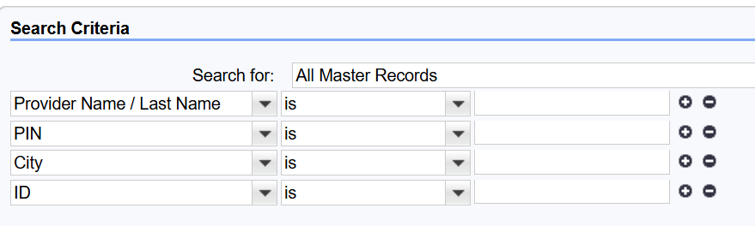
5. | Employee Responsible | is  contains  starts with  is between  is less than  is greater than | F4 Help - on first click opens 1a screen  1a. Search condition for each field below –  is, contains, starts with  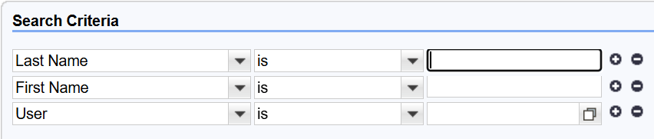  1b. User – on clicking F4 help opens screen below with search condition is  is not  contains  starts with  is empty  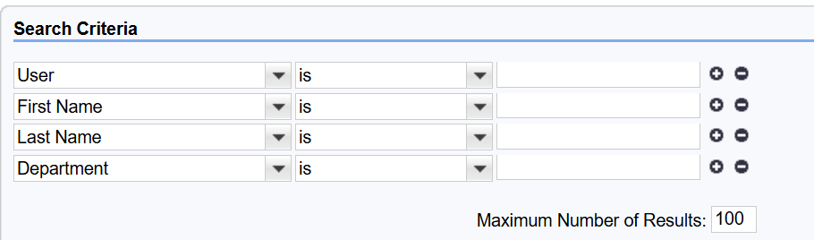
6. | NDC Code | Is  Contains  Starts with | F4 Help – on first click opens 1a screen  1a. Search condition for each field below –  1. NDC - free form  is  contains  starts with  is between  is less than  is greater than  2.NDC Description – free form  is  Contains  Starts with  3.Brand – free from  is  is not  contains  starts with  is empty  4.Availability – F4 help (Available for Vaccine request, All products)  is  is not  contains  starts with  is empty  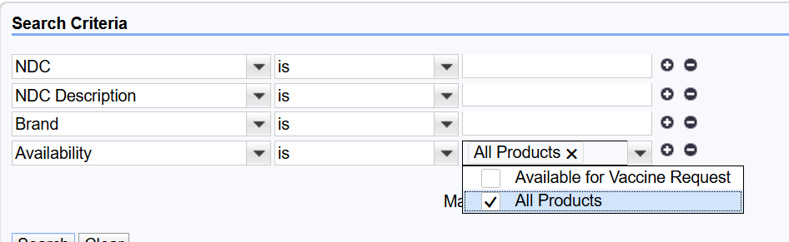
7. | Create Date | is  is between  is earlier than  is later than | Date options  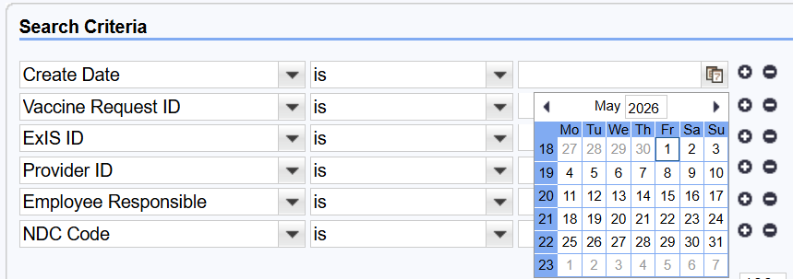
8. | Employee Responsible Last Name | is  Contains  Starts with | Free from
9. | Contact | is  contains  starts with  is between  is less than  is greater than  is empty | F4 Help – on clicking f4 help, it opens 1a screen with the below search fields and all the fields with search condition as  Is  Contains  Starts with  1a.  Contact Last Name – free from  Contact First Name – free from  Employee Responsible ID – F4  Provider ID – F4  Contact ID – free form  Sales Employee ID – F4  Provider Name – free form  Territory ID – free form  Contact Relationship – drop down ()  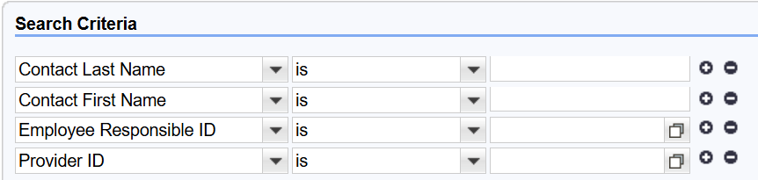  1b. Employee Responsible – on clicking F4  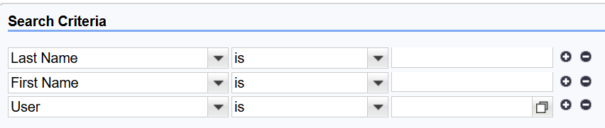  On clicking user F4 help  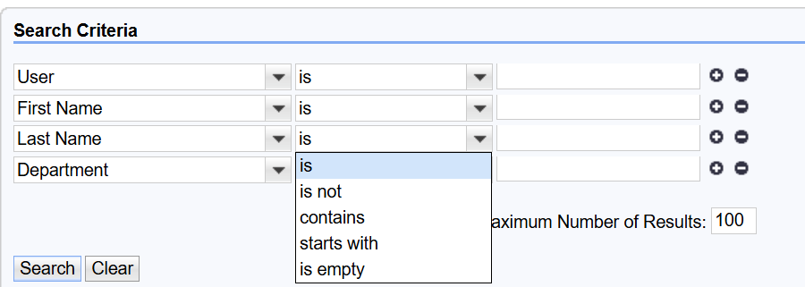  1c. Provider ID – on clicking F4 help  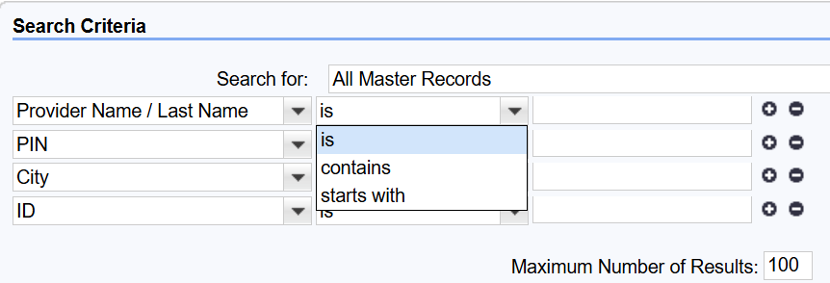  1d. Sales Employee Id – on clicking F4 help  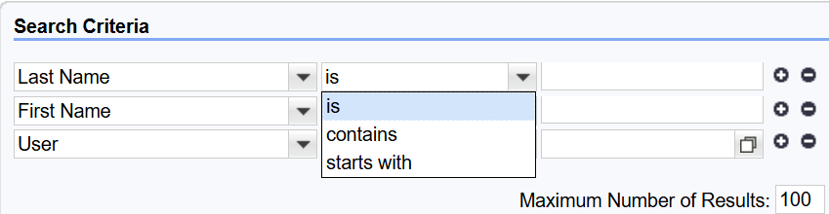  User F4 help  1e. Contact Relationship – Drop down  Values – available and not available  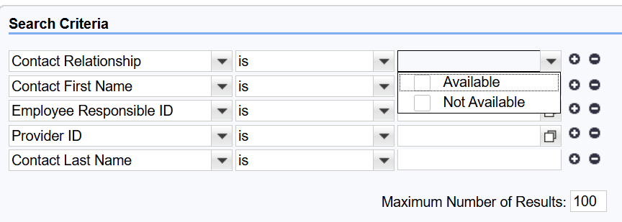
10. | Ship – to – party | is  Contains  Starts with | Free form
11. | Ship-To Party ID | is  contains  starts with  is between  is less than  is greater than | F4 Help – on clicking opens below screen  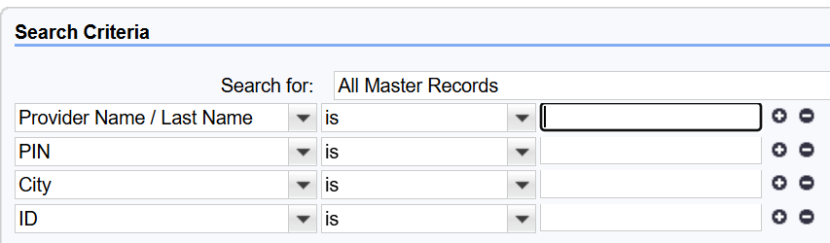
12. | Created By | Is  Is not | F4 Help – opens below screen  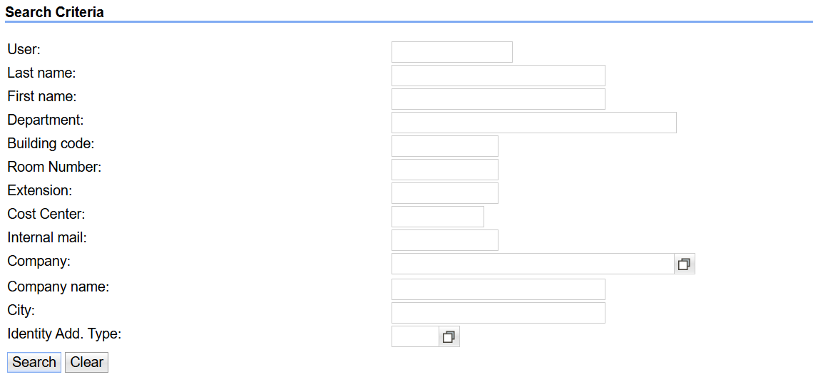
13. | Sales Order Type | Is  Is not | Drop Down  Values : Return Replacement  Vaccine request
14. | Status | is | Drop Down – displays all the statues
15. | Grantee | is | Drop Down – displays all the sales offices
16. | Priority | is | Drop Down –  Values – Normal  High
17. | Delivery Block Reason | is | Drop Down –  Values – Back Order
18. | Rejection Reason | is | Drop down  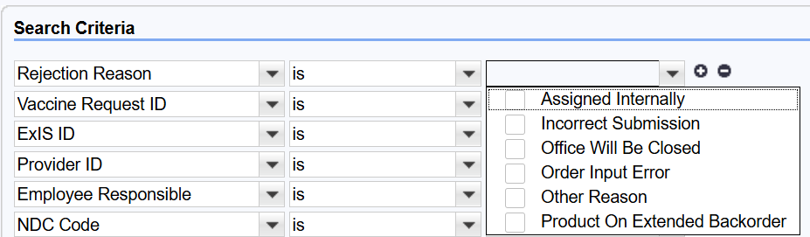

The selected option shall determine how the entered value is evaluated during the search execution.

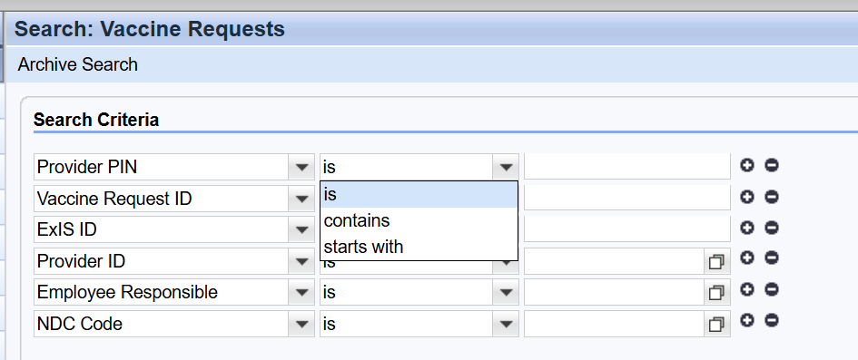

Once search is completed, the user should have the ability to save the search and export list to Excel

- List request - based on above search criteria
The layout of the results should be as below.
    - Go TO Vaccine Request
    - Description
    - Provider ID
    - GO TO Provider
    - Status
    - GO TO Provider Contact
    - Created At
    - Created By
    - Employee responsible

  - Copy from existing vaccine request: Ability to create vaccine request for the existing vaccine request from the top of the Vaccine Request Header Section by clicking the Copy button. Prepopulated from the original (Header)
    - Description if text was in the field
    - Provider
    - Provider Address
    - Contact
    - Employee Responsible
    - Category defaults to Internet Sales can select from dropdown, EXIS, Provider e-mailed, Provider Faxed, Provider Telephone, VACMAN
    - Status: defaults to 1A in Process Request can select 1B Order on Hold-Request, 1E Approved by Grantee-Req, IF Cancelled-Request
    - Net Value defaults to the amount
    - Tax Amount defaults to zero
    - Gross Value defaults to Zero
    - All values default to USD
  - Prepopulated from Item section
    - Item Number
    - Brand
    - NDC Code
    - NDC Description
    - Qty
    - Unit of Measure
    - Order Intention

    - Delivery Status (defaulted to not delivered)
    - Net Value if applicable
Fund type will not copy over from order line but populates based on fund split template.

  - Will have to complete any additional fields that are required to complete the request if not prepopulated already i.e. Fund type and any error messages will have to be addressed once saved.
  - Exceptions during copying -
- Though fund type does not carry over into the copied order, the PAN fund type associated with the NDC prepopulates in the copied order.
- Opt-out ancillary kit does not transfer into the copied order; instead the rules of the ancillary kit table are applied.

Access Method or Path
Will leverage the existing CRM custom table and custom transaction code naming convention wherever possible.
Custom transactions will be available directly from the SAP Fiori page as easy-to-use tiles for authorized users.
Execution:
Custom Transaction Code/Fiori Tile : ________
Custom Fiori App. : ________
Standard Transaction Code/Fiori Tile : VA01/va02/va03
Standard Fiori App. : Manage Sales Order
Other : _________

Required Custom Table
NA

User Interface Screen Flow
The UI screen flows are illustrative mockups (current CRM screens as reference) will be included in FSD and will be updated with FIORI screens during the Build phase once the screens are developed.
Below are the reference screens from CRM

Create - screens with all the assignment blocks
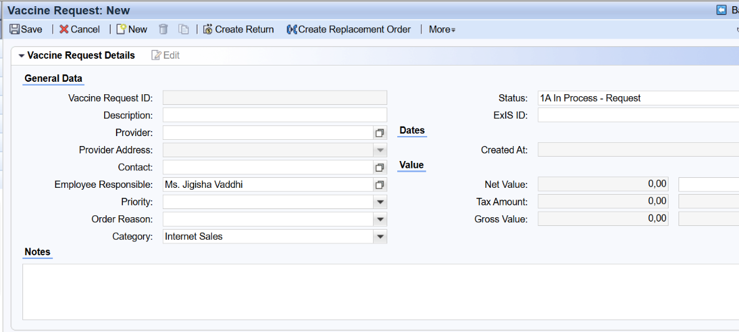
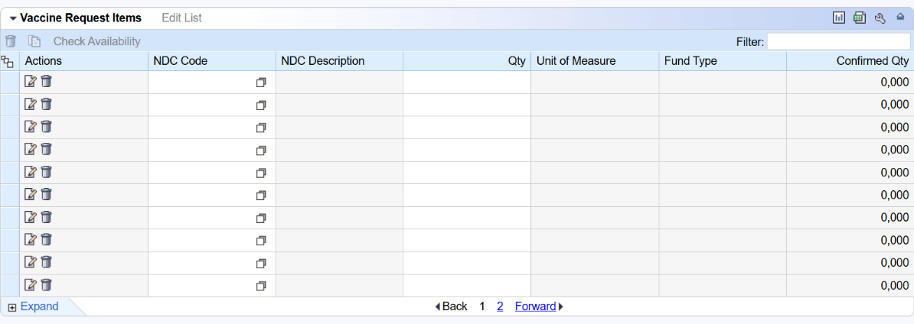
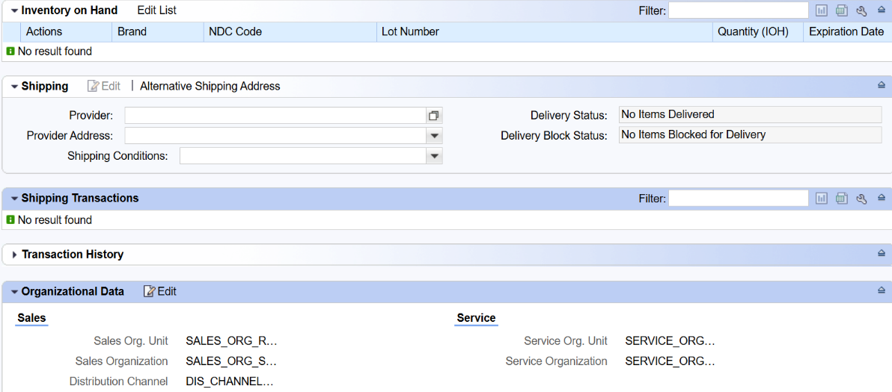
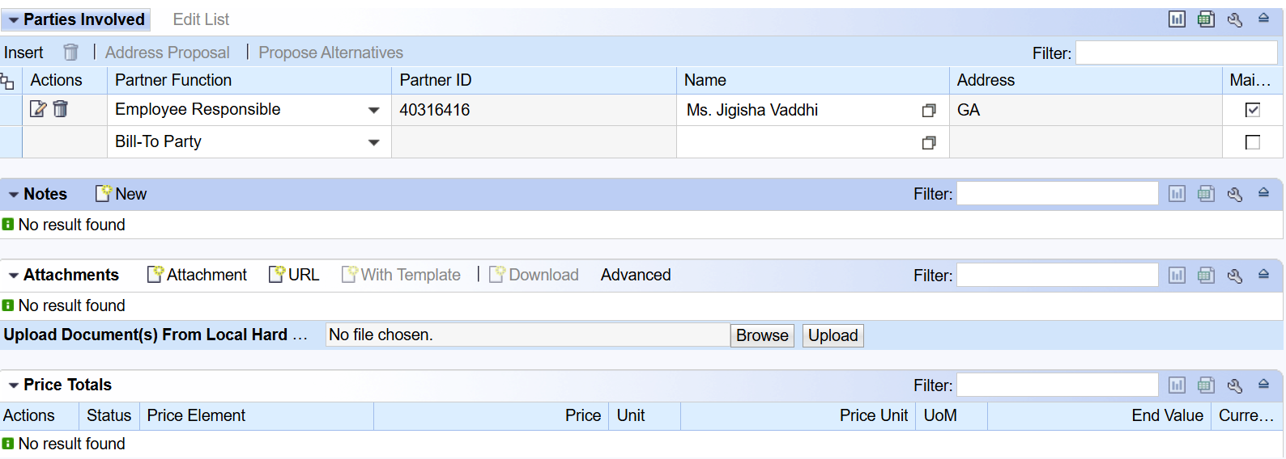
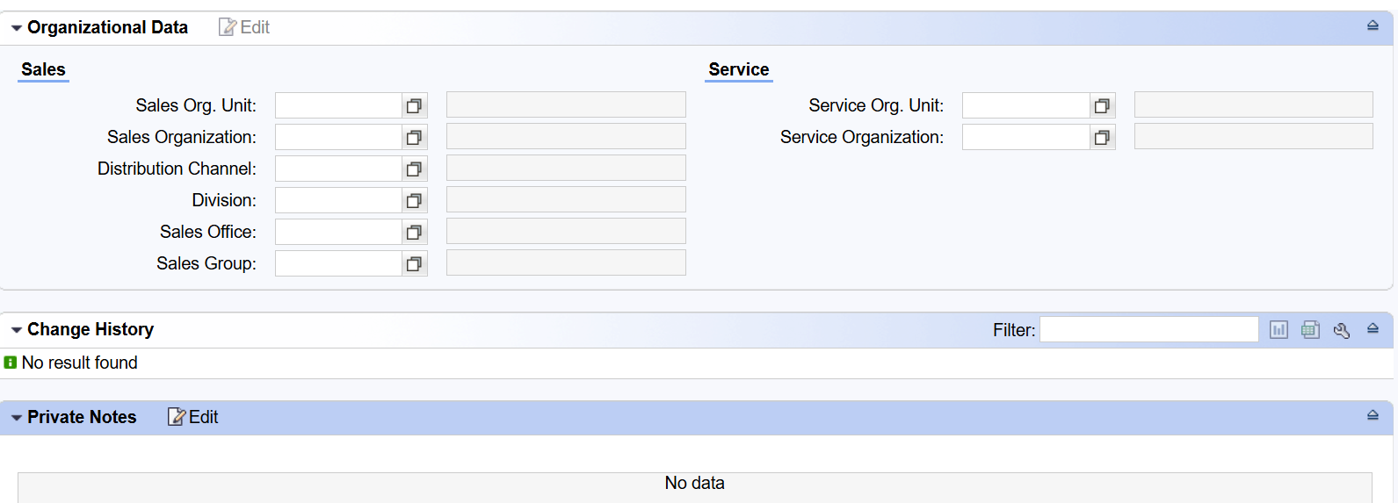

Display / Edit
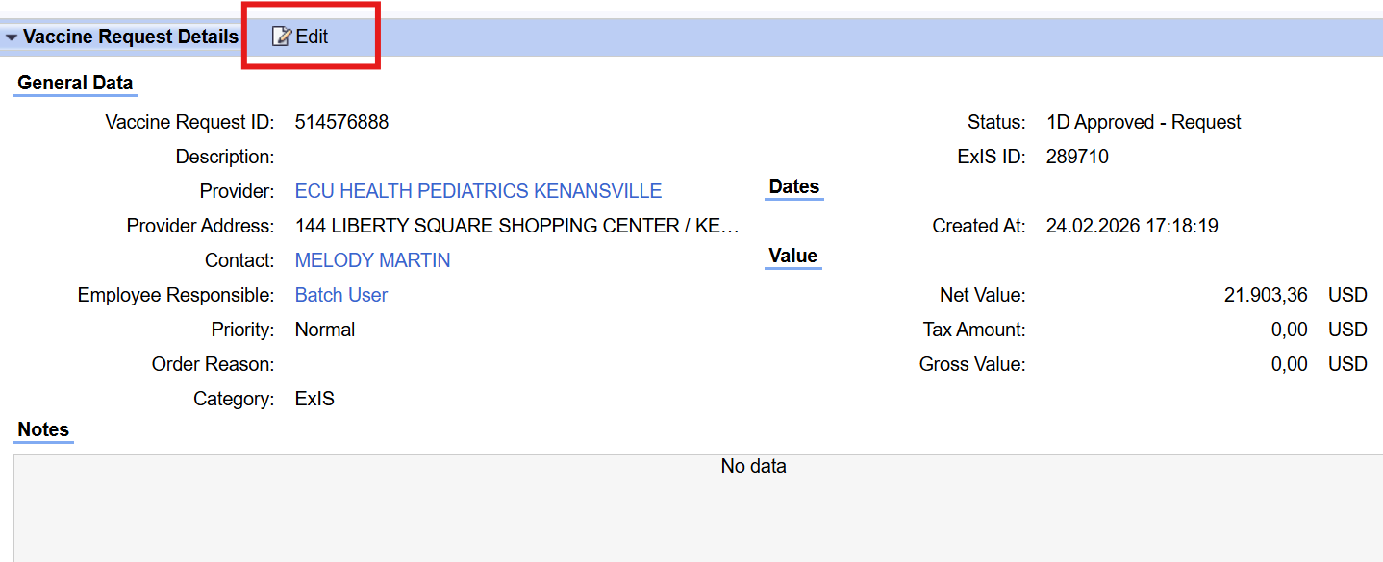
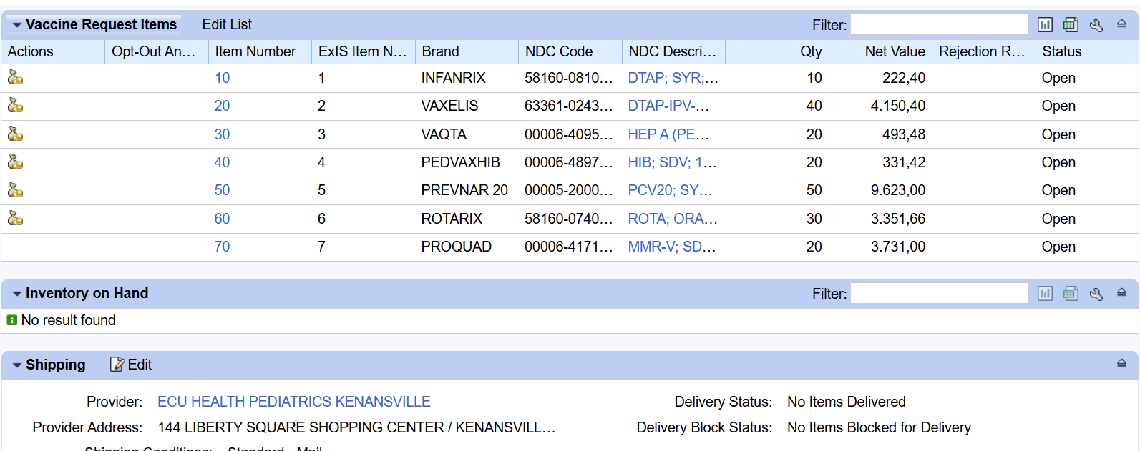
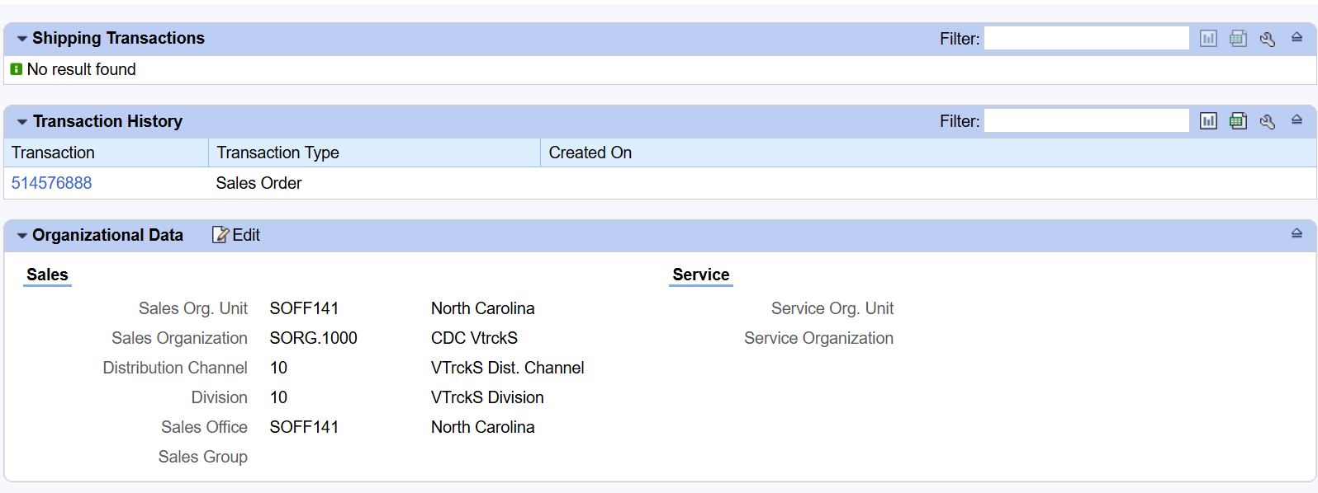
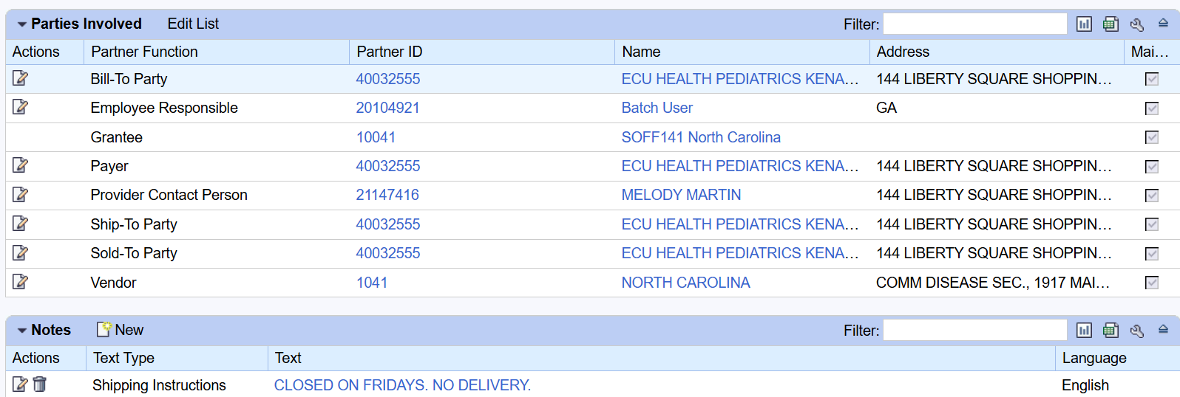
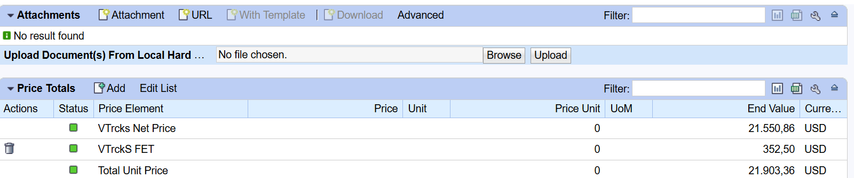
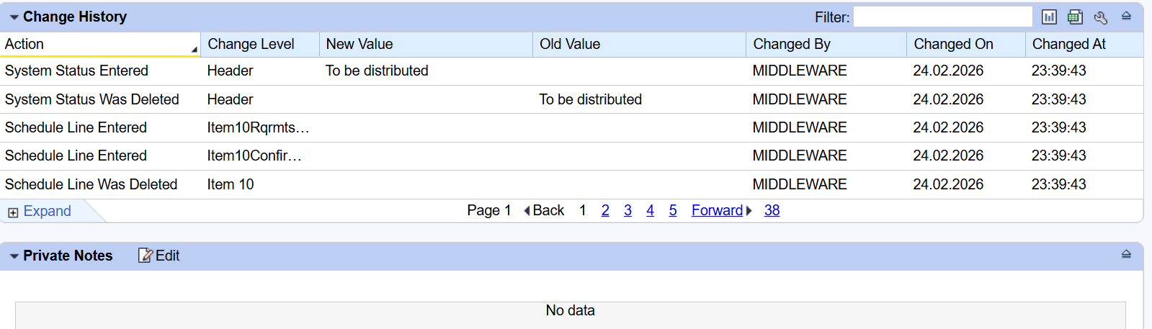

Search / List
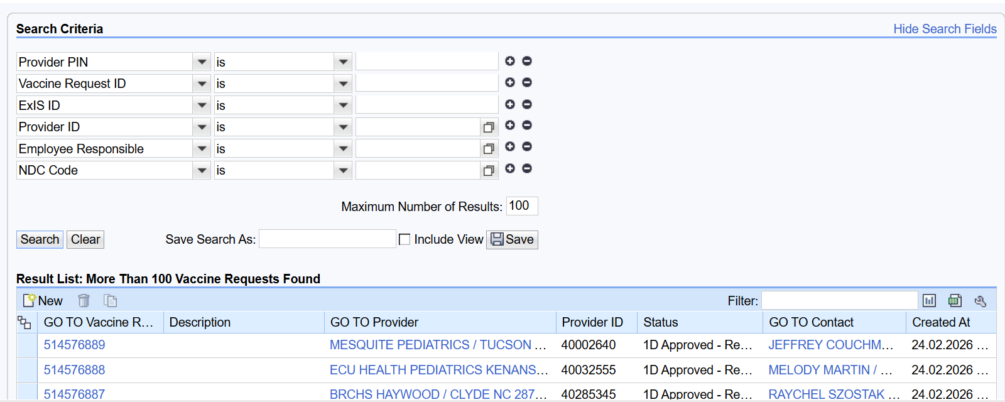

User Interface Screen Layout
NA

User Interface Screen Field List

Field Label | Data Type | Field Size | Mandatory | Range Required | Reference Table & Field Name | Field Control Type | Display Format
Header
Vaccine Request ID | CHAR | 10 | No | No | VBAK-VBELN | Display | Numeric
Description | CHAR | 50-100 | No | No | VBAK-BSTNK | Editable | Free text
Provider | CHAR | 10 | Yes | No | VBAK-KUNNR | SEARCH HELP
Provider Address | CHAR | 255 | Yes | No | VBPA- | Display
Contact | CHAR | 10 | Yes | No | VBPA-PARVW | Value Help
Employee Responsible | CHAR | 12 | No | No | VBPA- | Default | User Id
Priority | CHAR | 2 | Yes | No | VBAK-LPRIO / VSBED | Dropdown
Order Reason | CHAR | 3 | No | No | VBAK-AUGRU
Category | CHAR | 10 | Yes | No | -
Status | CHAR | 2 | No | No | VBUK- |  | Status text
Exs ID | CHAR | 20 | No | No | - |  | Numeric
Created At | DATS |  | No | No | - |  | Date /Time
Net Value (currency + amount) | CURR |  | No | No | - |  | Currency
Tax Amount (currency + amount) | CURR |  | No | No | - |  | Currency
Gross Value (currency + amount) | CURR |  | No | No | - |  | Currency
Notes (free-text area) |  |  |  |  | -
Item
Item Number | NUMC | 6 | No | No | VBAP-POSNR |  | Numeric
EXIS Item Num | CHAR | 20 | No | No |  |  | Alphanumeric
Brand | CHAR | 20 | No | No |  |  | Text
NDC Code | CHAR | 18 | Yes | No | VBAP-MATNR |  | Numeic
NDC Description | CHAR | 40 | No | No | VBAP-ARKTX
Quantity | QUAN |  | Yes | No | VBAP-KWMENG
Unit of Measure | Unit | 3 | Yes | No | VBAP-VRKME
Fund Type | CHAR | 10 |  | No | -
Opt-Out Ancillary | CHAR | 1 |  | No | -
PO Reference | CHAR | 20 |  | No | - |  | Text
Delivery Status | CHAR | 1 | No | No | VBUP-LFSTA |  | Status
Net Value | CURR |  | No | No | VBAP-NETWR |  | Currency
Rejection Reason | CHAR | 2 | No | No | VBAP-ABGRU | Dropdown | Text
Submitted Quantity | QUAN |  | Yes | No | VBAP-KWMENG |  | Numeric
Currency | CURR | 5 | No | No | VBAK-WAERK | Display | Currency
Status | CHAR | 1 | No | No | VBUP-GBSTA/LFSTA |  | Status
Product category | CHAR |  | No | No | MARA-MATKL |  | TexT
item category | CHAR | 4 | Yes | No | VBAP-PSTYV |  | Text
Last confirmed delivery date | DATS |  | No | No | VBEP-EDATU |  | Date
Item object type | CHAR | 10 |  | No | VBAP-POBJT |  | Text
Batch | CHAR | 10 |  | No | VBAP-CHARG | Value Help | Batch
Fixed Date / Qty | CHAR | 1 | No | No | VBEP-FIXMG |  | Indicator
Plant | CHAR | 4 |  | No | VBAP-WERKS | Value Help | Numeric
Condition Amount | CURR |  | No | No | KONV-KBETR |  | Currency
Condition Currency | CURR |  | No | No | KONV-KONWA |  | Currency
Order Intention | CHAR | 10 | No | No |  | Dropdown | Text
Confirmed quantity | QUAN |  | No | No | VBEP-BMENG
Delivered quantity | QUAN |  | No | No | LIPS-LFIMG
Goods issue qty | QUAN |  | No | No | LIPS-LGMNG
Goods issue qty unit | UNIT | 3 | No | No | LIPS-VRKME
Billed qty | QUAN |  | No | No | VBRP-FKIMG
Billed Value | CURR |  |  |  | VBRP-NETWR
Higher level item | NUMC |  |  |  | VBAP-UEPOS
Item Usage | CHAR |  |  |  | VBAP-
Condition Price unit 1 |  |  |  |  | KONV-
condition Type 1 |  |  |  |  | KONV-
Condition unit 1 |  |  |  |  | KONV-
Condition Value 1 |  |  |  |  | KONV-
Inventory on Hand
Actions |  |  | No | No |  | Manual | Button
Brand | CHAR | 20 | No | No |  | Display | Text
NDC Code | CHAR | 18 | Yes | No |  | Value Help
Lot Number | CHAR | 10 |  | No |  | Value Help | Numeric
Quantity | QUAN |  | No | No |  |  | Numeric
Expiration Date | DATS |  | No | No |  |  | Date
Shipping
Provider | CHAR | 10 | Yes | No | VBPA-KUNNR | Value Help
Provider Address | CHAR | 255 | No | No | VBPA-ADRNR | Display
Shipping Conditions | CHAR | 2 | Yes | No | VBAK-VSBED | Dropdown
Delivery Status | CHAR | 1 | No | No | VBUP-LFSTA | Display
Delivery Block Status | CHAR | 2 | No | No | VBAK-LIFSK | Dropdown
Shipping Transactions
Transaction | CHAR | 20 | No | No | VBAK-VBELN | Display
Transaction Type | CHAR | 40 | No | No | VBAK-AUART | Display
Created On | DATS |  | No | No | VBAK-ERDAT | Display
Transaction History
Organizational Data
Sales Org Unit | CHAR | 4 | Yes | No | VBAK-VKORG
Slaes Organization | CHAR | 4 | Yes | No | VBAK-VKORG
Distribution Channel | CHAR | 2 | Yes | No | VBAK-VTWEG
Division | CHAR | 2 | Yes | No | VBAK-SPART
Slaes Office | CHAR | 4 | No | No | VBAK-VKBUR
Sales group | CHAR | 3 | No | No | VBAK-VKGRP
Service org unit |  |  |  |  | -
Service organization |  |  |  |  | -

User Interface Processing Details
NA

User Interface Error and Exception Handling Details

Error Logging Process | Notification/Reporting Procedure | Process for Error Resolution
Validation errors triggered during provider UI entry are captured at UI level | System displays real time error messages on the screen | User must correct highlighted fields before proceeding
Mandatory item validation | Error message displayed at item level “Inavlid or blocked NDC” | User must enter a valid and active NDC using value help / manual correction
Contact validation | Error message dispalyed inline for incorrect format | User must correct format before proceeding
Ordering intention validation | Error message displayed when missing | User must select appropriate ordeing intention
Quantity validation | System throw error if invalid or auto adjusts where ever applicable | User reviews adjusted quabtity or corrects manully before save
High Priority order without order reason | Error message displayed | User must enter order reason before submission
Ancillary quantity exceeds vaccine quantity | Error message ddispalyer at item level | User must adjust quantities to comply with business rules
Inventory on Hand submission without required fields | Error message displayed for missing fields | User must enter all the mandatory fields before submission
IoH submission without any field update | Error message: ‘ Atleast one quantity update is required for IoH submission’ | User must update at least one quantity field before submission
Temp log submission without required text update | Error message displayed on submission | User must enter required text before proceeding
Doses administered submission without age group data | Error message : ‘At least one age group entry is required’ | User must enter atleast one age group value
Invalid Date range | Error message : ‘From date must be earlier than To date’ | User must enter the correct date range
Invalid NDC during manual entry | Error message : ‘Invalid or Inactive NDC’ | User must select a valid NDC using value help or correct entry
Pandemic ancillary quantity exceeds vaccine quantity | Error message : ‘Ancillary quantity cannot exceed vaccine quantity’ | User must adjust ancillary quantities accordingly
Ancillary item without corresponding pandemic vaccine item | Error message displayed at item level | User must add corresponding vaccine item or remove ancillary item

Performance Requirements
NA

Security and Controls

Security Requirements
Awardees users should be able to flag only their Jurisdiction data. CDC users should be able to flag for any Awardees

Object Type | Name | Transaction Code | Authorization Group | Level of Security
Enhancement | E008 – Fiori-Awardee-UI-Orders | VA01 | TBC | TBC

Role | Transaction Code(s) | Level of Security
TBC | VA01 | TBC

Auditing and Control Requirements
NA

Functional Unit Test Scenarios
Note: Once the Functional Unit testing is completed, a FUT walkthrough session will be conducted to go through the test results.

Step  # | Test Type | Test Title | Steps Performed | Expected Results | Actual Results
1. | Positive | Create Order Via Fiori | Launch Fiori app, Click create, Enter header and Item fields | Sales order created in VA01
2. | Positive | Header Data mapping to va01 | Enter Provider, Order reason, Priority and Save | Fields mapped correctly
3. | Positive | Item data mapping to va01 | Enter NDC and quantity and Save | Item created in VBAP with correct MATNR
4. | Positive | Auto Population from BP | Select Provider, and check Address and Contact | Address and contact auto populated
5. | Positive | Save order | Enter partial data and click save | Order saved with status ‘In Process’
6. | Negative | Invalid NDC, Quantity | Enter invalid material and enter zero quantity | Error message displayed
7. | Negative | Business Rule Failure | Enter invalid data | Order status set to Rejected status
8. | Positive | Edit Existing order | Open saved order and edit fields and save | Changes updated in VA02
9. | Positive | Cancel Order Before Approval - Awardee | As Awardee user, open an order with "Rejected" status. Cancel the order. Enter rejection reason. | Order status is updated to "Cancelled-Request." Committed budget and SPC allocation are released
10. | Positive | Cancel Direct Ship Line Item After Approval - CDC User | As CDC user, open an approved order with a direct ship line item. Cancel the direct ship line item. | Direct ship line item is cancelled Direct ship line item is cancelled. Budget and SPC allocation for that line item are released. Order status reflects partial cancellation.
11. | Negative | Awardee Attempts to Cancel Direct Ship Line After Approval | As Awardee user, open an approved order with a direct ship line item. Attempt to cancel the direct ship line item | System prevents cancellation. Error message indicates Awardee does not have permission to cancel direct ship items after approval.
12. | Positive | Search Provider Orders | Navigate to order search screen. Enter Provider PIN as search criterion. Execute search | List of provider orders matching the Provider PIN is displayed, regardless of order status.
13. | Positive | Display Provider Order Details | From the order list, select a provider order. Open order details. | Full order details are displayed including partner functions (sold-to, ship-to, bill-to), NDC codes, quantities, order status, and order dates.
14. | Positive | Submit IoH During Order Creation | During Fiori order creation, navigate to the IoH section. Verify that IoH is pre-populated from consignment stock (NDC, Lot Number, Qty, Expiration Date). Adjust quantities if needed. Submit order. | IoH is created with status "Submitted." Provider order is created. Consignment stock adjustments are reflected
15. | Positive | Validate business rules | Validate the business rule captured in E006 FSD during provider order creation / change | During the provider order creation all the applicable business rules are passed and order is created successfully
16. | Positive | Validate UI business rules | Validate the UI business rules during provider order creation / change | During the provider order creation all the applicable UI business rules are passed and order is created successfully

Attachments and Documentation
NA

